

**Department of Computer Science and Engineering**

**DEEP LEARNING LAB – CSE 3183**

***Mini Project on***

**Driver Drowsiness Detection**

**Group members:**

**Name: Bhavya Marupura**

**Register no: 210962168**

**Section: B**

**Roll no: 50**

**Name: Mogili Sai Krishna Vaibhav**

**Register no: 210962200**

**Section: B**

**Roll no: 56**

**Department of Computer Science and Engineering**

**Manipal Institute of Technology, Manipal.**

**April 2024**

Driver Drowsiness Detection – Deep Learning

BHAVYA MARUPURA  
*Department of Computer Science   
Manipal Institute of Technology*Manipal, India  
marupurub@gmail.com  
SAI KRISHNA VAIBHAV  
*Department of Computer Science   
Manipal Institute of Technology*Manipal, India  
krishnavaibhav2110@gmail.com

*Abstra*ct— In this study, we present a comprehensive approach to driver drowsiness detection using the Ultralytics YOLO implementation, a robust production-ready framework built on PyTorch. Leveraging the base YOLO model trained on the COCO dataset with 80 different classes, we fine-tuned the model for drowsiness detection. Our method involves real-time detection using a webcam to determine whether the driver is awake or drowsy, with potential applications in automotive safety systems. We also discuss the installation process of Ultralytics YOLO, labeling images in YOLO format, and the overall workflow of our approach. Our findings demonstrate the effectiveness of using YOLO for real-time drowsiness detection, highlighting its practicality and potential for implementation in various safety-critical environments. This research aims to contribute to enhancing driver safety, particularly in automotive applications.

**Keywords— Deep Learning, PyTorch, Ultralytics YOLOv5, Drowsiness Detection, Computer Vision, Image Labelling, OpenCV, COCO Dataset, Real-Time Detection**

# Introduction

Drowsiness, characterized by a strong urge to sleep, can lead to decreased response time, intermittent lack in attention, and brief episodes of microsleeps (short, involuntary periods of sleep lasting more than 500 milliseconds). The impact of inadequate sleep affects thousands of drivers on highways, including taxi and truck drivers, as well as individuals undertaking long journeys. Furthermore, drowsiness diminishes drivers' attentiveness, resulting in unsafe conditions. This significantly heightens the risk of drivers missing important road signs or exits, drifting into adjacent lanes, or being involved in accidents, making it a major factor in road accidents.

Due to the absence of drowsiness detection systems in Advanced Driver Assistance Systems (ADAS), many drivers and pedestrians suffer serious injuries as a result of drowsy driving. According to data from the US National Highway Traffic Safety Administration, there have been 50,000 injuries and nearly 800 deaths reported, with 91,000 traffic accidents attributed to drowsiness [1]. In 2005, the National Sleep Foundation reported that 60% of drivers admitted to driving while drowsy in the previous year [2], and an estimated 6,400 people died annually in crashes involving drowsy driving [3]. The Foundation for Traffic Safety also stated that from 2009 to 2013, 21% of all fatal crashes involved a drowsy driver [4].

Driver drowsiness is a significant factor in road accidents, contributing to thousands of fatalities worldwide each year. Detecting drowsiness in drivers and alerting them in a timely manner can prevent accidents and save lives. In recent years, computer vision techniques have shown promise in detecting driver drowsiness through the analysis of facial features and behavior. One such technique is the use of deep learning models, which can process large amounts of data and make real-time decisions.

In this study, we focus on the development of a driver drowsiness detection system using the Ultralytics YOLO framework. YOLO, short for "You Only Look Once," is a state-of-the-art object detection system that can detect objects in images and videos with remarkable speed and accuracy. The Ultralytics YOLO framework is a production implementation built using the PyTorch deep learning framework, known for its efficiency and ease of use in research and development.

Our research paper addresses the urgent requirement for a reliable drowsiness detection model to mitigate the risks associated with drowsy driving. In this study, we introduce a deep learning system for drowsiness detection implemented using PyTorch. We propose a novel approach for extracting the Region of Interest (ROI) by utilizing a specially designed pre-trained architecture based on YOLOv5.

In this paper, we focus on leveraging the strengths of the Ultralytics YOLO framework to develop a robust and real-time driver drowsiness detection system. Our primary aim is to refine the pre-existing YOLO model using a customized dataset specifically designed for drowsiness detection. This dataset consists of images depicting individuals in both awake and drowsy states, with each image annotated to indicate the subject's current state. These annotated images serve as the foundation for training the model to accurately detect and differentiate between awake and drowsy states in drivers.

Additionally, we aim to provide insights into future directions for enhancing road safety through advancements in drowsiness detection technology. Our ultimate goal is to contribute to the improvement of road safety by developing more effective methods and technologies for identifying and preventing accidents caused by driver drowsiness.

# LITERATURE REVIEW

Numerous studies have explored the automatic detection of driver drowsiness using various machine learning and computer vision techniques. Many of these studies have employed datasets containing images or videos of drivers exhibiting signs of drowsiness, often captured in simulated or real driving scenarios. These datasets play a crucial role in training and evaluating models for drowsiness detection. Additionally, some research has focused on using wearable sensors to monitor physiological signals, such as heart rate and eye movements, to detect drowsiness in real-time. This article provides a brief overview of some of these papers.

In [5], novel framework that combines vision transformers with YOLOv5 architectures to improve driver drowsiness recognition. The framework includes a custom YOLOv5 pre-trained architecture designed for accurate face extraction, with a focus on extracting the Region of Interest (ROI). Unlike previous architectures, this framework incorporates vision transformers for binary image classification. The model is trained and validated on the UTA-RLDD public dataset, achieving impressive accuracies of 96.2% for training and 97.4% for validation. The proposed framework undergoes further evaluation on a custom dataset featuring 39 participants in diverse lighting conditions, boasting an impressive 95.5% accuracy. The experimentations underscore the practical potential of this framework for applications in smart transportation systems, highlighting its efficacy in real-world scenarios.

In the study [6], a new system for detecting driver drowsiness is introduced, which combines deep learning models with IoT techniques. Implemented at the Toyota Technical Education Program center, the system uses a dataset enriched with diverse videos of drowsy drivers, containing 21,542 facial images that capture different states and contexts of drowsiness. The proposed models for detecting drowsiness, such as LSTM, VGG16, Inception-V3, and DenseNet, demonstrate improved effectiveness by considering the changing signs of drowsiness over time. By utilizing transfer learning and integrating an emotion classification model, these models improve accuracy by analyzing facial features. Notably, the system is able to accurately detect drowsiness even when drivers are wearing glasses and masks, providing reliable warnings to enhance road safety.

introduced an innovative approach for detecting driver drowsiness using IoT and deep neural networks in their study [7]. The method combines LSTM, VGG16, InceptionV3, and DenseNet architectures, enhancing accuracy by integrating multiple drowsiness signs and considering time-varying factors. When fatigue is detected, the system issues a warning through the Jetson Nano monitoring system. The approach achieves an impressive 98% accuracy and is effective even when drivers wear masks and glasses, making it relevant for ensuring road safety, especially during the Covid-19 pandemic.

study [8], proposed a model that assesses driver fatigue levels by analyzing changes in eyeball movement using a convolutional neural network (CNN). The system uses both CNN and VGG16 models to detect and classify facial expressions related to sleepiness into four categories: open, closed, yawning, and no yawning. Tested on a dataset of 2900 images with diverse features, including gender, age, head position, and illumination, the CNN model achieves an accuracy rate of 97%, precision of 99%, and recall and F-score values of 99%. In contrast, the VGG16 model achieves an accuracy rate of 74%, marking a significant improvement over existing methods for similar challenges.

This study [9] explores drowsiness detection based on eye-blink patterns, using custom data for model training and validating outcomes across different individuals. By tracking landmarks in the eye and mouth regions, the analysis focuses on eye-blinking rates and mouth shape changes represented in real-time fluctuations. The study finds a strong correlation between yawning and closed eyes as indicators of drowsiness. The detection model achieves high accuracy, with 95.8% for drowsy-eye detection, 97% for open-eye detection, 0.84% for yawning detection, 0.98% for right-sided falling, and 100% for left-sided falling. Additionally, the method enables real-time eye rate analysis, categorizing eyes into "Open" and "Closed" states using a threshold.

The study [10] details essential functional and non-functional requirements for a driver drowsiness detection system. These include video input, eye and blink detection, EAR calculation, drowsiness detection, alert mechanisms, and user settings, as well as parameters like accuracy, speed, robustness, portability, security, and user-friendliness. Beyond technical specifications, the study introduces a sophisticated system that uniquely integrates machine learning algorithms with physiological signals, specifically utilizing electroencephalogram (EEG) and electrocardiogram (ECG). This approach promises an advanced and multifaceted system for detecting and preventing driver drowsiness, combining technological and physiological aspects.

The paper [11] discusses improving road safety by detecting driver drowsiness. Their method involves detecting the face, tracking the eyes, and matching the data with a dataset to identify drowsiness. The system can alert when the eyes are closed for too long and adjusts the score based on eye states, showing a proactive mechanism. Their aim for 80% accuracy is noteworthy for reducing accidents. This research offers a practical solution for enhancing road safety.

The study [12] discusses the global concern of road accidents, with a focus on driver drowsiness. Their proposed solution involves a driver drowsiness detection system that uses CNN-machine learning algorithms to assess eye blink rate and eyeball size through a camera. This real-time approach is implemented offline for practicality and includes an alert system that uses alarms to proactively address drowsy driving. The paper offers a technology-driven solution to tackle this critical aspect of driver behavior, making a valuable contribution to road safety.

In her work, [13] focuses on identifying drowsiness in drivers using 60-second sequences of visible facial images. She presents two solutions that prioritize reducing false positives. The first solution combines recurrent and convolutional neural networks, while the second uses deep learning techniques to derive numeric features from images and integrates them into a fuzzy logic-based system. Despite similar accuracy rates of around 65% on training data and 60% on test data for both solutions, the fuzzy logic-based system stands out with a high specificity of 93%, effectively minimizing false alarms. While the achieved results may not be entirely satisfactory, these proposed methods serve as a promising starting point for future research in the field.

study [14] focuses on addressing driver drowsiness in road safety using deep learning models. They compare three CNN architectures—VGG19, EfficientNetB7, and MobileNetV2—on a dataset of annotated driver-eye images. The results show that deep learning models, particularly EfficientNetB7 and MobileNetV2, achieve high accuracy rates of 99.87% and 99% respectively, surpassing conventional methods. This research highlights the importance of selecting suitable models for drowsiness detection, considering factors like computational complexity and real-time performance. It contributes valuable insights to improving road safety by leveraging deep learning technology.

study [15] tackles the issue of drowsy driving, a major cause of road accidents. They develop a lightweight real-time drowsiness detection model using Deep Learning, specifically the MobileNet method. By using facial landmarks and an adaptive threshold technique, their system accurately detects signs of driver drowsiness, offering timely warnings to prevent accidents. Training the model resulted in an accuracy of about 91.59% with a 88.10% validation accuracy. Future plans involve refining the training process and optimizing the model for use as a lightweight embedded system, potentially deployable in vehicles to prevent accidents due to drowsy or fatigued driving.

research [16] focuses on tackling driver drowsiness, a major cause of road accidents, with an Intelligent Drowsiness Detection System (IDDS) using Deep Convolutional Neural Network (DCNN) models. They evaluate VGG16, InceptionV3, and Xception DCNN models in detecting drowsiness from eye closure features in video recordings. The study finds that the Xception model performs best in validation accuracy and loss metrics. Real-time testing confirms Xception's effectiveness, suggesting it could be used in cost-effective computing devices for vehicle installations. The system could also be applied to speed control in electric vehicles (EVs) and alerting drivers to mitigate drowsy driving risks.

In his study [17], proposes a Convolutional Long Short-Term Memory (ConvLSTM) neural network for real-time drowsiness detection, aiming to improve road safety. The model extracts features from specific regions of interest on the driver's face using AI algorithms. With impressive accuracy rates of 99.44% on the Yawn Eye dataset and 90.12% on the MRL dataset, their approach shows promise for both small and large datasets. They suggest integrating their models with Advanced Driver Assistance Systems (ADAS) for more comprehensive road safety measures.

Author addresses the critical issue of fatal road accidents caused by driver drowsiness, highlighting the need for proactive measures to enhance road safety in his study [18]. They propose a driver drowsiness detection framework using an LSTM recurrent neural network model trained on the RLDD dataset. Their framework achieves commendable accuracies in training, validation, and testing, outperforming previous methods. The inclusion of an aggregator module enables the implementation of various detection policies and customization of outputs based on drowsiness severity. This research significantly contributes to improving road safety by enhancing detection accuracy and minimizing false positives. Future efforts will focus on refining the model to further improve accuracy and reduce false positives, ultimately aiming to mitigate fatalities and severe injuries in road accidents.

In [19] investigates the use of Convolutional Neural Networks (CNNs) for drowsiness detection, emphasizing their ability to analyze images or videos, especially of human faces or eyes, to identify signs like drooping eyelids and yawning. Their proposed Sequential CNN model, aided by GPUs for initial data processing, aims for a 96% accuracy rate in detecting and classifying sleepiness. This research enhances safety by addressing risks associated with drowsiness, opening avenues for further exploration in sleepiness detection and classification.

Tamal focuses on driver drowsiness detection to reduce accidents caused by fatigue. Their research [20] develops a real-time system using Convolutional Neural Networks (CNNs) to detect drowsiness based on eye and mouth states. Training the CNN model on two factors and four features achieves an impressive average accuracy of 97.23%, surpassing previous works. This contribution highlights the importance of technology in road safety and accident prevention. The authors emphasize addressing drowsy driving and suggest further exploring CNN's potential with other neural networks for future advancements.

Author[21] address driver sleepiness as a major cause of road accidents, proposing a two-dimensional CNN-based model to detect and categorize drowsiness using facial images. Their model outperforms other techniques like VGG-16 and ResNet-50, achieving a 96% accuracy rate. By using deep convolutional neural networks to extract facial information and classify drivers into yawning and non-yawning states, they aim to reduce fatalities and enhance travel conditions by alerting fatigued drivers in real-time. This study highlights the potential of image-based techniques and deep learning algorithms in improving road safety.

In [22], Author looks at the challenge of using deep learning in real-time applications, specifically for detecting drowsy drivers. They note that while deep learning is accurate, the models are often too large, making them slow and memory-intensive. To solve this, they propose using knowledge distillation to make the models smaller while keeping them accurate. By training a simpler model with a more complex one, they reduce the size while maintaining a 95% accuracy rate on the ZJU dataset. This work suggests that knowledge distillation could be useful for making deep learning models faster and more efficient in real-time applications.

in his paper [23] address road accidents caused by driver drowsiness. Their model utilizes Transfer Learning and OpenCV, employing CNNs to detect drowsiness by analyzing facial features, particularly focusing on the eyes. Training the model on an eye dataset, they achieve a precision rate exceeding 87.4%. The authors emphasize the importance of their model's accuracy in preventing accidents and reducing fatalities attributed to drowsy driving. They also discuss potential enhancements, such as incorporating additional sensors and improving camera technology, to further improve its effectiveness. This study highlights the promising role of visual computing technology in averting road accidents and safeguarding lives.

In her study [24] proposed a real-time drowsiness detection model using deep learning techniques to address road accidents caused by drowsy drivers. Their system employs CNNs to analyze facial landmarks from an onboard camera, accurately identifying signs of driver fatigue with a 95.5% accuracy rate. Upon detection, the model triggers a buzzer alarm to prompt the driver to take precautions. By leveraging techniques like the Haar-cascade method for feature extraction and SoftMax classification for categorization, the model effectively distinguishes between drowsy and alert states. Through training on categorized data representing different facial expressions and states, the model demonstrates robust performance and potential in reducing road accidents due to driver fatigue.

Authors focus on developing advanced in-vehicle systems to address fatigued and distracted driving in their study [25]. Their proposed mechanism monitors and authenticates driver identities by analyzing indicators such as head orientation, eye movement, yawning, and ocular condition. By tracking eye and lip movements and triggering alarms for prolonged eye closure, the system aims to alert owners if drowsiness persists. Using deep learning, specifically Convolutional Neural Networks (CNN) in MATLAB with mounted cameras, the system achieves a 99% success rate in real-time drowsiness detection. This approach aims to enhance road safety and reduce accidents caused by driver fatigue, aligning with the goal of promoting safer driving practices.

In [26], addresses the critical issue of driver drowsiness leading to road accidents. They propose a driver drowsiness detection system using computer vision-based machine learning models, specifically OpenCV and CNN. By analyzing the driver's face and eyes for signs of drowsiness like drooping eyelids and yawning, the system aims to alert drivers promptly. Through the integration of AI techniques and various algorithms, the authors achieve a high accuracy rate of 99%, demonstrating effectiveness in accurately detecting drowsiness. Their approach shows promise in improving road safety and reducing accidents caused by driver drowsiness.

Authors propose[27] a study to tackle road accidents caused by driver drowsiness, a major concern according to the National Highway Traffic Safety Administration (NHTSA). They introduce a novel approach based on deep learning, specifically convolutional neural networks (CNN), to accurately detect drowsiness using drivers' facial features, focusing on the eyes and mouth regions. Their CNN model achieves a high accuracy of 94.95%, even under challenging conditions like low light and different angles, and when drivers wear transparent glasses. The results suggest the potential of CNN for driver drowsiness detection, with possibilities for further improvements using larger datasets and advanced CNN architectures. Overall, their research underscores the need for robust and reliable driver drowsiness detection systems to enhance road safety and reduce accidents.

The study conducted by the authors[28] addresses the fundamental problem of road accidents in India, mainly due to drowsy driving. While existing methods focus on fatigue detection, the authors propose a new method that not only detects fatigue in Indian drivers but also predicts wakefulness by looking at them face to face. By extracting and calculating the results from facial analysis, the authors learned a lot of deep learning to achieve the accuracy of drowsy driver prediction. Optimization studies using UTA's real life sleepiness dataset, especially for the Indian context, prove the important truth in predicting sleep. Among the test models, the decision tree model is the best, reaching the highest Squared value of 93.65% and the lowest error. This study contributes to the field by providing a predictive method for detecting sleepiness that has the potential to reduce crashes caused by drowsy driving. The best performance of the decision tree model makes it the optimal choice for predicting drowsy drivers in given data, enabling future integration with vehicle systems such as advanced driver assistance (ADAS) or other IoT devices for instant feedback and control operations. promise.

The study[29] addresses the pressing issue of tired driving, which has become a significant cause of car accidents in recent years, leading to serious injuries, fatalities, and financial losses. By utilizing a fusion deep learning algorithm (FDLA), the authors aim to accurately determine the level of driver fatigue in real time, leveraging facial expressions and eye movements as key indicators. This novel approach integrates CNN and FDLA to track the driver's fatigue level, focusing on facial key points to identify critical areas for fatigue detection. The proposed driver care solution utilizes face recognition and tracking to assess the driver's tiredness, providing reliable results even in diverse situations. Through rigorous testing, the system demonstrates robustness and consistency in identifying driver fatigue, offering potential applications in real-time driving assistance systems. The FDLA algorithm enhances the effectiveness of the CNN model, enabling rapid processing and accurate fatigue detection, thereby contributing to the advancement of driver safety technologies.

This paper[30] represents a significant advancement in the realm of vehicle security and driver safety, offering a comprehensive solution that integrates facial recognition, drowsiness detection, and IoT technologies, including 5G/6G connectivity and edge computing. The research underscores the importance of addressing driver distraction and fatigue to mitigate accidents effectively. By employing a two-phase approach, the study demonstrates a holistic strategy for enhancing security measures and accident prevention in intelligent transport systems. The successful demonstration of the project at Nokia's facilities underscores the practical applicability of the proposed solution, showcasing its effectiveness in simulated environments. The utilization of advanced technologies such as 5G modems and edge computing enables real-time data processing, ensuring prompt authentication and drowsiness detection. The study's findings highlight the system's potential to revolutionize automotive security and safety standards, paving the way for future deployments in vehicles to prevent accidents caused by driver fatigue.

# RESEARCH GAP AND OBJECTIVES

While research into drowsiness detection using Deep Learning, PyTorch, and Computer Vision tools has demonstrated promising results, there remains a notable gap. Although the model mentioned above works well, some issues need to be addressed.

Investigating methods to enhance the real-time adaptability of drowsiness detection systems, considering the variability in individual sleep patterns and dynamic driving conditions.

Addressing the challenge of long-term monitoring, especially for extended journeys, by developing systems that can effectively track and respond to drowsiness over extended periods.

Investigating effective intervention strategies beyond alarms, such as adaptive lighting, seat vibrations, or auditory cues, to proactively prevent drowsiness-related incidents.

Enhancing the speed and precision of drowsiness detection in real-time, especially during driving, is essential for reducing reaction times and preventing accidents. By investigating methods to improve the effectiveness of detection algorithms, helps to minimize delays in identifying drowsiness, thus improving driver safety in critical moments.

Drowsiness detection systems must perform reliably under various conditions, including different lighting environments, driver appearances, and vehicle types. The generalization of drowsiness detection models across diverse environmental and driver conditions poses a significant challenge, indicating a need for more robust and adaptable algorithms.

The availability of high-quality labeled data is essential for training accurate machine learning models. However, creating large-scale datasets for drowsiness detection can be challenging and time-consuming.

Integrating drowsiness detection systems into existing in-vehicle safety systems presents technical and practical challenges. Ensuring seamless compatibility and reliability with diverse vehicle architectures and safety protocols is crucial for widespread adoption.

The effectiveness of drowsiness detection systems depends not only on their technical capabilities but also on how well they interact with users. Designing intuitive user interfaces and alarms that effectively communicate the driver's drowsiness status and trigger appropriate responses is essential for ensuring user acceptance and compliance.

To address these gaps and limitations, the objectives are twofold:

The primary objective is to evaluate the system's performance in real-world scenarios, focusing on its ability to accurately and quickly detect drowsiness, which is crucial for preventing accidents.

Another key objective is to explore ways to enhance the system's detection capabilities and efficiency. This includes investigating methods to improve the speed and accuracy of drowsiness detection, particularly in time-critical situations such as driving, thus filling the existing gaps and mitigating inherent limitations.

# METHODOLOGY

Research papers on driver drowsiness detection utilize a range of Deep Learning algorithms, including Convolutional Neural Networks (CNNs), Long Short-Term Memory (LSTM) networks, Recurrent Neural Networks (RNNs), and Deep Convolutional Neural Networks (DCNNs). Specific architectures such as VGG16, VGG19, InceptionV3, Xception, MobileNetV2, and EfficientNetB7 are employed for feature extraction and classification tasks.

The methodology of this project revolves around implementing a real-time drowsiness detection system using the Ultralytics YOLO framework. This framework, known for its efficiency in object detection, will be leveraged to detect signs of drowsiness in drivers. The methodology for each step is as follows:

## Installing and Importing Dependencies

Library Imports: Initial setup and import of essential libraries for a computer vision project, specifically for implementing a drowsiness detection system using the YOLOv5 model.

* *PyTorch*, a deep learning library, and its associated image and audio components are installed.
* *YOLOv5* repository, a model for object detection, is cloned. Within the YOLOv5 directory, dependencies are installed from the requirements.txt file to ensure all necessary tools are available for running the YOLOv5 model.
* *Torch* library is imported for deep learning tasks, *cv2* for image processing, *numpy* for numerical operations, and *matplotlib*.*pyplot* for plotting graphs and images.

These libraries play a crucial role in working with images and training the AI model for driver drowsiness detection.

## Loading Model

Loading a pre-trained YOLOv5 model for object detection.

YOLOv5 is a deep learning model used to detect objects in images or videos, and it's known for its speed and accuracy.

By loading this model, we can detect objects like cars, people, and signs of drowsiness in drivers from images or videos. This model has been trained on a large dataset to recognize these objects accurately, making it useful for tasks where quick and precise object detection is needed, such as driver drowsiness detection.

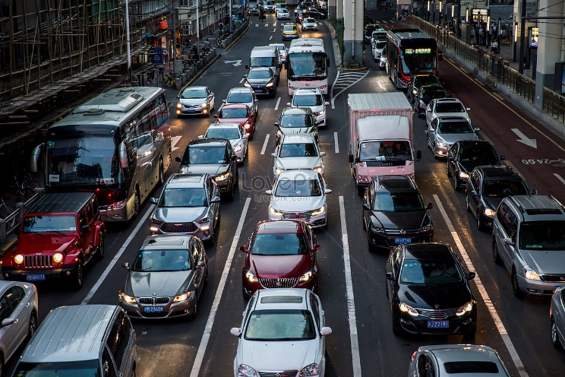

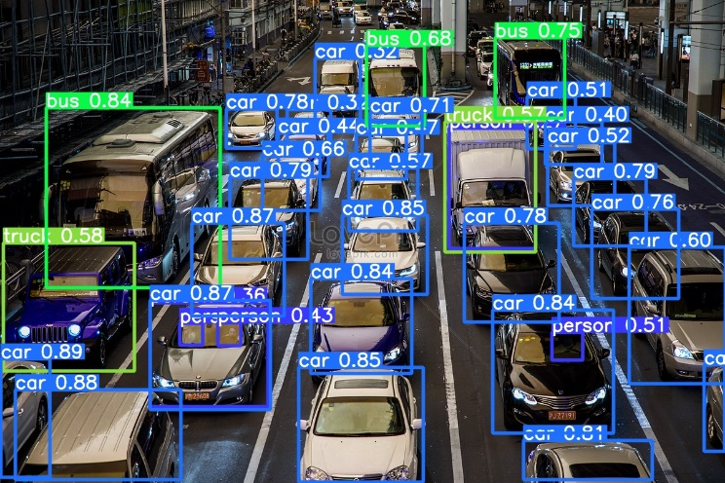

Fig.1.YOLOv5 Model detects 5 persons, 26 cars, 3 buss, 2 trucks

Confidence Score: The confidence score is a float value indicating how confident the model is that the detected object exists in the bounding box. Higher confidence scores typically indicate a higher likelihood of the object being correctly detected.

## Getting the Images Ready

In this project, we have a dataset of images that includes pictures of people who are either awake or drowsy. The goal is to organize these images and ensure that the AI model can differentiate between images showing awake people and those showing drowsy people.

## Labelling the Images

LabelImg: LabelImg is a graphical image annotation tool used for labeling images with bounding boxes. We use it to manually label our images as either "awake" or "drowsy" for training our model. This process is crucial for training the model to recognize different states, such as determining whether a person in an image is awake or drowsy.

After cloning LabelImg and installing the necessary dependencies, each image is opened in LabelImg, and bounding boxes are drawn around the faces of individuals, with labels indicating whether they are "awake" or "drowsy". This annotation process is essential for the accurate training of the AI model to detect drowsiness in real-world scenarios..

## Getting the Model Ready for Training

A YAML file is created that acts as a guide for our model. This file tells the model where to locate the images and how many different types of images there are—whether they show people who are awake or drowsy. The file contains a dictionary with class numbers and their respective names.

## Training the Model

Once we load our custom model we initiate the training of the model using a specified dataset containing images of individuals in either a drowsy or awake state.

The model is trained to recognize whether a person in an image is awake or drowsy, using the images and their corresponding labels.

The objective is to train the model to differentiate between an awake and a drowsy person in an image by adjusting its internal parameters (weights) during each training epoch. This adjustment aims to enhance the model's ability to make precise predictions when presented with new, unseen images.

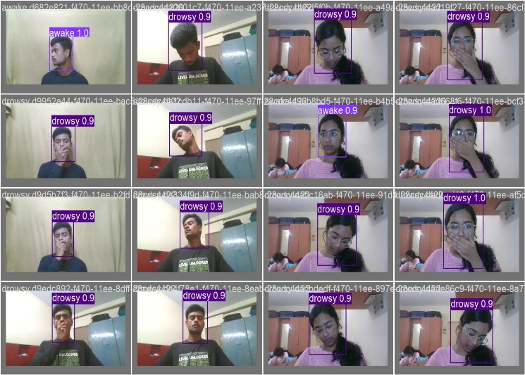

Fig.2. Training and Validation Batch[0]

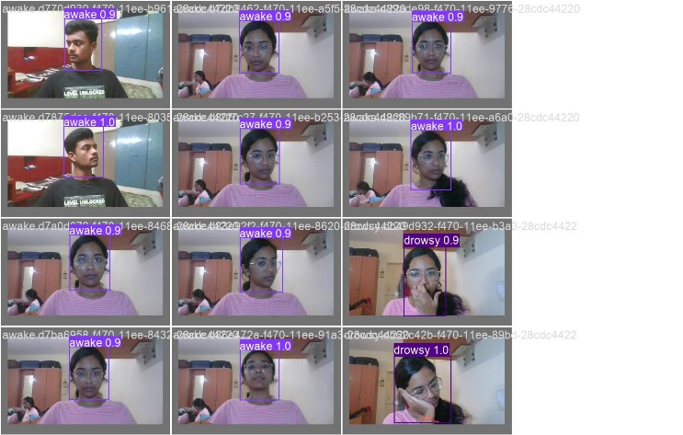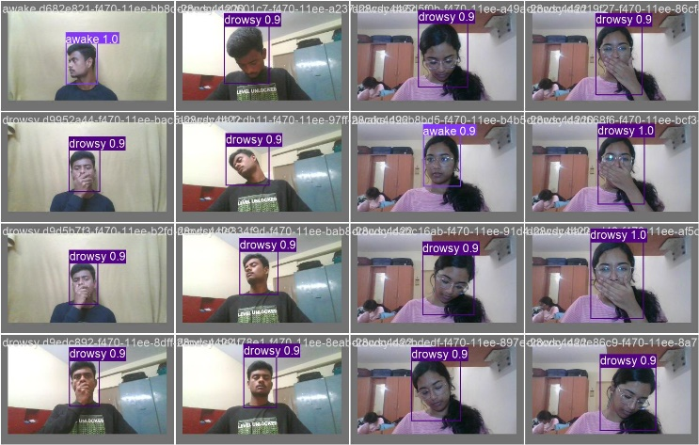

Fig.3. Training and Validation Batch[1]

## Testing the Model

The model is tested using new images that it has not encountered previously. The aim is to verify the model's ability to accurately determine whether a person in an image is awake or drowsy.

For each unseen image, the model processes the image and returns a result in YOLOv5 format, which includes the class number, x and y coordinates, width, and height of the detected object.

This information is then used to display the image using OpenCV, showing the label indicating whether the individual in the image is drowsy or awake.

# DISCUSSION AND RESULTS

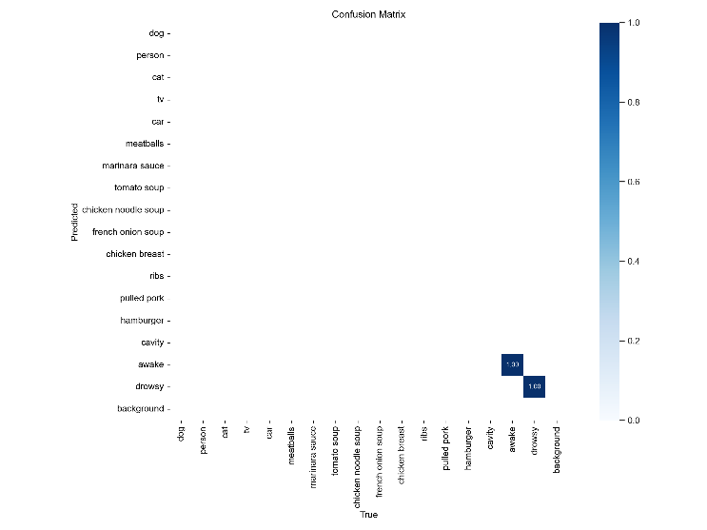

Fig.4. Confusion Matrix – provides a comprehensive overview of the model's performance by indicating all the classes it recognizes and displaying the labels present in the dataset.

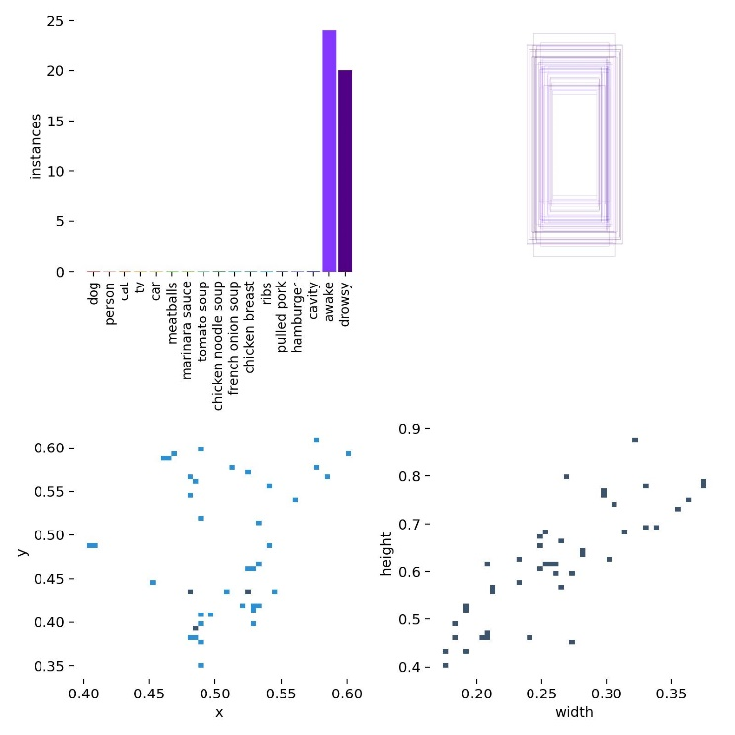Fig.5. Labels depicts classes or categories that the model has been trained to recognize.

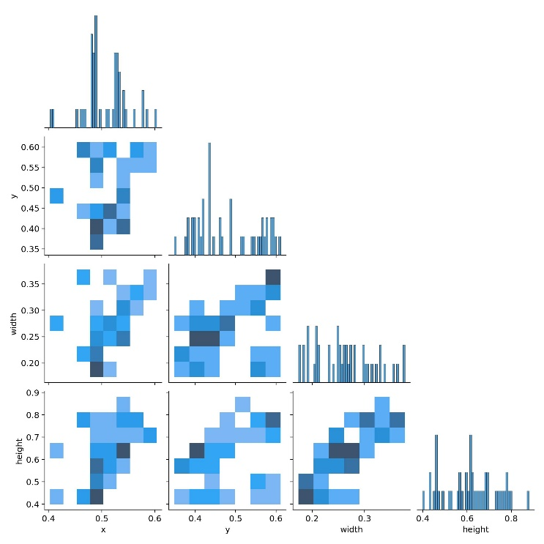Fig.6. Label Correlogram - generated to analyze the performance of the model in distinguishing between different classes. For example, if the model frequently confuses the "person" class with the "bicycle" class, this would be reflected in the correlogram as a higher correlation between these two labels.

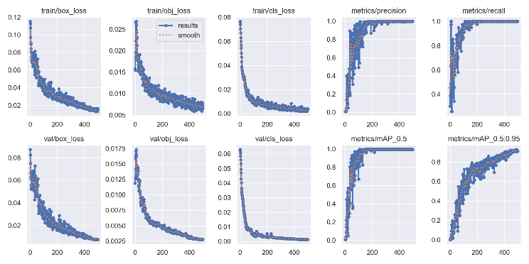

Fig7. Loss vs Epoch Fig.8. Precision vs Epoch

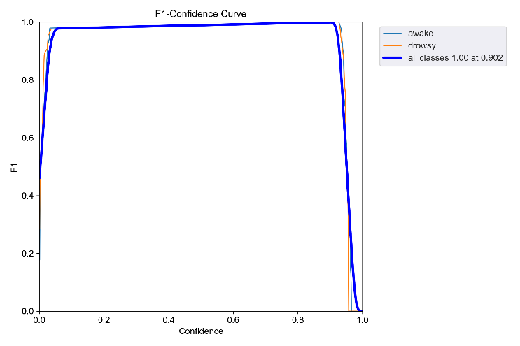

Fig.9. The curve shows how the F1 score changes as the confidence level threshold for classifying predictions as positive or negative varies. A high F1 score at a given confidence level indicates that the model is able to achieve a balance between precision and recall at that threshold.

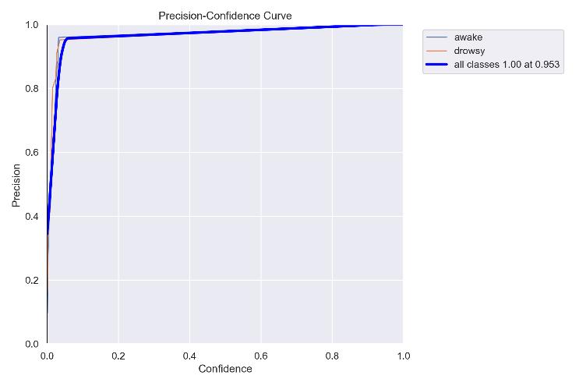

Fig.10. The curve shows how the precision of the model's predictions changes as the confidence level threshold for classifying predictions as positive or negative varies. A high precision at a given confidence level indicates that the model is making accurate positive predictions at that threshold.

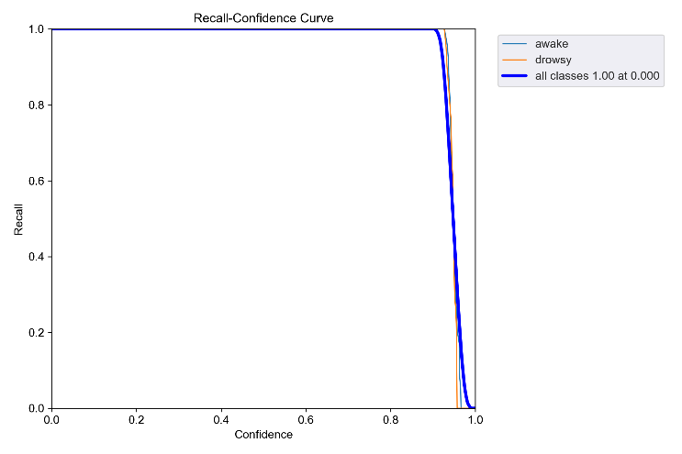

Fig.11. The curve shows how the recall of the model's predictions changes as the confidence level threshold for classifying predictions as positive or negative varies. A high recall at a given confidence level indicates that the model is able to capture a large proportion of actual positive instances at that threshold.

# CONCLUSION AND FUTURE WORK

In conclusion, the project successfully developed a driver drowsiness detection system using the Ultralytics YOLO framework, showcasing the effectiveness of Deep Learning and Computer Vision in enhancing road safety. The system's implementation involved fine-tuning the YOLOv5 model on a custom dataset tailored for drowsiness detection, enabling accurate identification of drowsiness cues in drivers.

The project's findings highlight the importance of leveraging advanced technologies like Deep Learning and Computer Vision in addressing critical issues such as drowsy driving. By utilizing state-of-the-art algorithms and methodologies, the system was able to detect drowsiness with high precision, showcasing its potential to significantly improve road safety.

Moving forward, there are several avenues for further exploration and enhancement of this project:

One area for improvement is the model's generalization across diverse driving conditions and environments. By collecting a more extensive and diverse dataset, including various lighting conditions, driver appearances, and vehicle types, the model could be trained to perform more reliably in real-world scenarios.

Another aspect to consider is the integration of additional sensor data, such as steering wheel movements and vehicle speed, into the drowsiness detection system. By combining these data sources with the existing visual cues, the system could gain a more comprehensive understanding of the driver's state and improve the accuracy of drowsiness detection.

Furthermore, the system's real-time performance could be optimized by exploring more efficient algorithms and hardware acceleration techniques. This could enable the system to run on resource-constrained devices, making it more suitable for deployment in vehicles without the need for high-end computing hardware.

Additionally, the system's user interface and alert mechanism could be further refined to ensure that alerts are timely and effective in capturing the driver's attention without causing distraction. Human factors studies could be conducted to evaluate the system's usability and effectiveness in real-world driving scenarios, providing valuable feedback for improvement.

Overall, future work on this project could focus on enhancing the system's accuracy, reliability, and practicality for real-world deployment, ultimately contributing to the advancement of driver safety technologies.

Top of Form

##### References

1. NHTSA, <https://www.nhtsa.gov/risky-driving/drowsy-driving>
2. SleepFoundation (2022), <https://www.sleepfoundation.org/drowsy-driving>
3. NSC, <https://www.nsc.org/road/safety-topics/fatigued-driver>
4. Tefft B.C. Prevalence of Motor Vehicle Crashes Involving Drowsy Drivers: Technical Report AAA Foundation for Traffic Safety, Washington, DC 20005 (2014)
5. Ghanta Sai Krishna, Kundrapu Supriya, Jai Vardhan, and Mallikharjuna Rao K (2022), Vision Transformers and YoloV5 based Driver Drowsiness Detection Framework, Data Science and Artificial Intelligence Department, IIIT Naya Raipur
6. [L. Agilandeeswari](https://link.springer.com/chapter/10.1007/978-3-031-27524-1_18#auth-L_-Agilandeeswari), [S. Nivetha](https://link.springer.com/chapter/10.1007/978-3-031-27524-1_18#auth-S_-Nivetha), [Tirthankar Chakraborty](https://link.springer.com/chapter/10.1007/978-3-031-27524-1_18#auth-Tirthankar-Chakraborty) and [Vikash Chand](https://link.springer.com/chapter/10.1007/978-3-031-27524-1_18#auth-Vikash-Chand) (2023), Study on Drowsiness Detection System Using Deep Learning, Proceedings of the 14th International Conference on Soft Computing and Pattern Recognition
7. Anh-Cang Phan, Thanh-Ngoan Trieu, and Thuong-Cang Phan (2023), Driver drowsiness detection and smart alerting using deep learning and IoT, Internet of Things
8. Mohammed Imran Basheer Ahmed 1, Halah Alabdulkarem, Fatimah Alomair, Dana Aldossary, Manar Alahmari, Munira Alhumaidan, Shoog Alrassan, Atta Rahman, Mustafa Youldash and Gohar Zaman, A Deep-Learning Approach to Driver Drowsiness Detection, Safety (2023).
9. Furkat Safarov, Farkhod Akhmedov, Akmalbek Bobomirzaevich Abdusalomov, Rashid Nasimov and Young Im Cho, Real-Time Deep Learning-Based Drowsiness Detection: Leveraging Computer-Vision and Eye-Blink Analyses for Enhanced Road Safety, Sensors (2023).
10. Dhiren Ojham, Amit Pawar, Gaurav Kasliwal, Roshani Raut, and Anita Devkar, Driver Drowsiness Detection Using Deep Learning, 2023 4th International Conference for Emerging Technology (INCET).
11. Jagbeer Singh, Ritika Kanojia, Rishika Singh, Rishita Bansal, and Sakshi Bansal, Driver Drowsiness Detection System – An Approach By Machine Learning Application, Meerut Institute of Engineering and Technology, Meerut, Journal of Pharmaceutical Negative Results (2022).
12. Harshit Verma, Amit Kumar, Gouri Shankar Mishra, Ujjwal Deep, Pradeep Kumar Mishra, and Parma Nand, Department of Computer Science & Engineering Sharda School of Engineering and Technology Sharda University, Greater Noida, Utter Pradesh, DRIVER DROWSINESS DETECTION, Journal of Data Acquisition and Processing (2023).
13. Elena Magán, M. Paz Sesmero, Juan Manuel Alonso-Weber and Araceli Sanchis, Driver Drowsiness Detection by Applying Deep Learning Techniques to Sequences of Images, Appl. Sci. 2022.
14. Dakshnakumar G S, J. Anitha, Investigation on Driver Drowsiness Detection using Deep Learning Approaches, Computer Science and Engineering Karunya Institute of Technology and Sciences Coimbatore, India 2023 International Conference on Circuit Power and Computing Technologies (ICCPCT)
15. P.S.Nandhini, S.Kuppuswami, Dr.S.Malliga ,P.Srinath, P.Veeramanikandan, Driver Drowsiness Detection using Deep Learning, Dept of CSE , Kongu Engineering College, Erode, India 2022 6th International Conference on Computing Methodologies and Communication (ICCMC)
16. Anirudh Suresh, Ankita S Naik, Arya Pramod, Ashwin Kumar N., Dr. Mayadevi N, Analysis and Implementation of Deep Convolutional Neural Network Models for Intelligent Driver Drowsiness Detection System, Department of Electrical Engineering, College of Engineering Trivandrum, India 2023 7th International Conference on Intelligent Computing and Control Systems (ICICCS)
17. Muhammad Saif Basit, Usman Ahmad, Jameel Ahmad , Khalid Ijaz, Syed Farooq Ali, Driver Drowsiness Detection with Region-of-Interest Selection Based Spatio-Temporal Deep Convolutional-LSTM, Dept. of Computer Science, SST UMT Lahore, Pakistan 2022 16th International Conference on Open Source Systems and Technologies (ICOSST)
18. Hrishikesh Khandare, Anjali Rajak, Rakesh Tripathi, A deep learning framework for non-intrusive driver drowsiness detection, Department of Information Technology, National Institute of Technology, India 2023 14th International Conference on Computing Communication and Networking Technologies (ICCCNT)
19. Kanwarpartap Singh Gill, Vatsala Anand, Rahul Chauhan, Siddhant Thapliyal, Rupesh Gupta, A Convolutional Neural Network-Based Method for Real-Time Eye State Identification in Driver Drowsiness Detection, Chitkara University Institute of Engineering and Technology, Chitkara University, Punjab, India, 2023 3rd International Conference on Smart Generation Computing, Communication and Networking (SMART GENCON) Karnataka, India. Dec 29-31, 2023
20. Tamal Ahmed, Oishi Jyoti, and Tamanna Hossain Mou, Drivers’ Drowsiness Detection System Enhancement Using Deep Learning: CNN-based Approach, Department of Electrical & Computer Engineering, Rajshahi University of Engineering & Technology Bangladesh 2023 26th International Conference on Computer and Information Technology (ICCIT) 13-15 December, Cox’s Bazar, Bangladesh
21. Jumana R, Chinnu Jacob, DEEP CNN BASED APPROACH FOR DRIVER DROWSINESS DETECTION Center for Artificial Intelligence, TKM College of Engineering, Kollam, Kerala 2022 IEEE International Power and Renewable Energy Conference (IPRECON)
22. Hitesh Ahuja ,Sumeet Saurav, Sahaj Srivastava, Chandra Shekhar, Driver Drowsiness Detection using Knowledge Distillation Technique for Real Time Scenarios, Department of Electrical and Electronics Engineering Birla Institute of Technology and Science Pilani, India 2020 IEEE 17th India Council International Conference (INDICON)
23. Sasi Preetham Ch , Shanmanth Guduru , Vinay Ronagala, Harisudha Kuresan, Samiappan Dhanalakshmi, Automatic System for Driver Drowsiness Detection System using Deep Learning, Department of Electronics and Communication Engineering Faculty of Engineering and Technology SRM Institute of Science and Technology, Kattankulathur 2023 International Conference for Advancement in Technology (ICONAT) Goa, India. Jan 24-26, 2023
24. V.Sree Varshitha,M. Mohamed Iqbal,V.Amrutha, P.Pujitha, DRIVER DROWSINESS DETECTION USING DEEP LEARNING, School of Computer Science and Engineering VIT-AP University Amaravathi, Andhra Pradesh India
25. DetectionDharam Buddhi,Poonam Negi, Deep Learning based Driver Drowsiness, Uttaranchal Institute of Technology Uttaranchal University Dehradun-248007, Uttarakhand, India
26. Devarakonda Sruthi, Avanaganti Amulya Reddy, G. Sai Siddaharth, Driver Drowsiness Detection System using Deep Learning, Department of AI, Anurag Group Of Institutions, Hyderabad. International Journal for Research in Applied Science & Engineering Technology (IJRASET),Volume 11 Issue IV Apr 2023
27. Dipender Singh and Avtar Singh, Enhanced Driver Drowsiness Detection using Deep Learning, Department of Computer Science and Engineering, Dr B R Ambedkar National Institute of Technology, Jalandhar, Punjab, India
28. Siddharth Kandwal, Shailendra Narayan Singh, Insiya Fatima, Department of CSE Amity School of Eng. & Tech Noida, Uttar Pradesh, India, Deep Learning Approaches for Drowsiness Prediction and Detection, 2024 11thInternational …, 2024 -ieeexplore.ieee.org.
29. Anand Singh Rajawat, Pawan Bhaladhare,School of Computer Science and Engineering, Sandip University, Nashik, India,Pradeep Bedi,Galgotias University, Greater Noida, India,Chaman Verma,Faculty of Informatics, University of Eötvös Loránd, Budapest, 1053, Hungary,Țurcanu Florin-Emilian,Department of Building Services, Faculty of Civil Engineering and Building Services, Gheorghe Asachi Technical University of Iasi, 700050, Jassy, Romania,Mihaltan Traian Candin,Faculty of Building Services Cluj-Napoca, Technical University of Cluj-Napoca, 400114, Cluj-Napoca, Romania, Real-Time Driver Sleepiness Detection and Classification Using Fusion Deep Learning Algorithm,Conference paper,First Online:02 May 2023,
30. Sonia Díaz-Santos, Óscar Cigala-Álvarez, Ester Gonzalez-Sosa, Pino Caballero-Gil, Cándido Caballero-Gil, Department of Computer Engineering and Systems, University of La Laguna, 38271 Tenerife, Spain eXtended Reality Lab, Nokia, 28045 Madrid, Spain, Driver Identification and Detection of Drowsiness while Driving Submission received: 5 February 2024 / Revised: 11 March 2024 / Accepted: 18 March 2024 / Published: 20 March 2024.